CASE STUDY
Flow: Creativity, Dance and Movement in Recovery
An arts-in-health project exploring the outcome of Creative Movement and Music sessions on the mood, confidence and social experience for patients in University Hospital Llandough’s (UHL) Stroke Rehabilitation Centre (SRC).
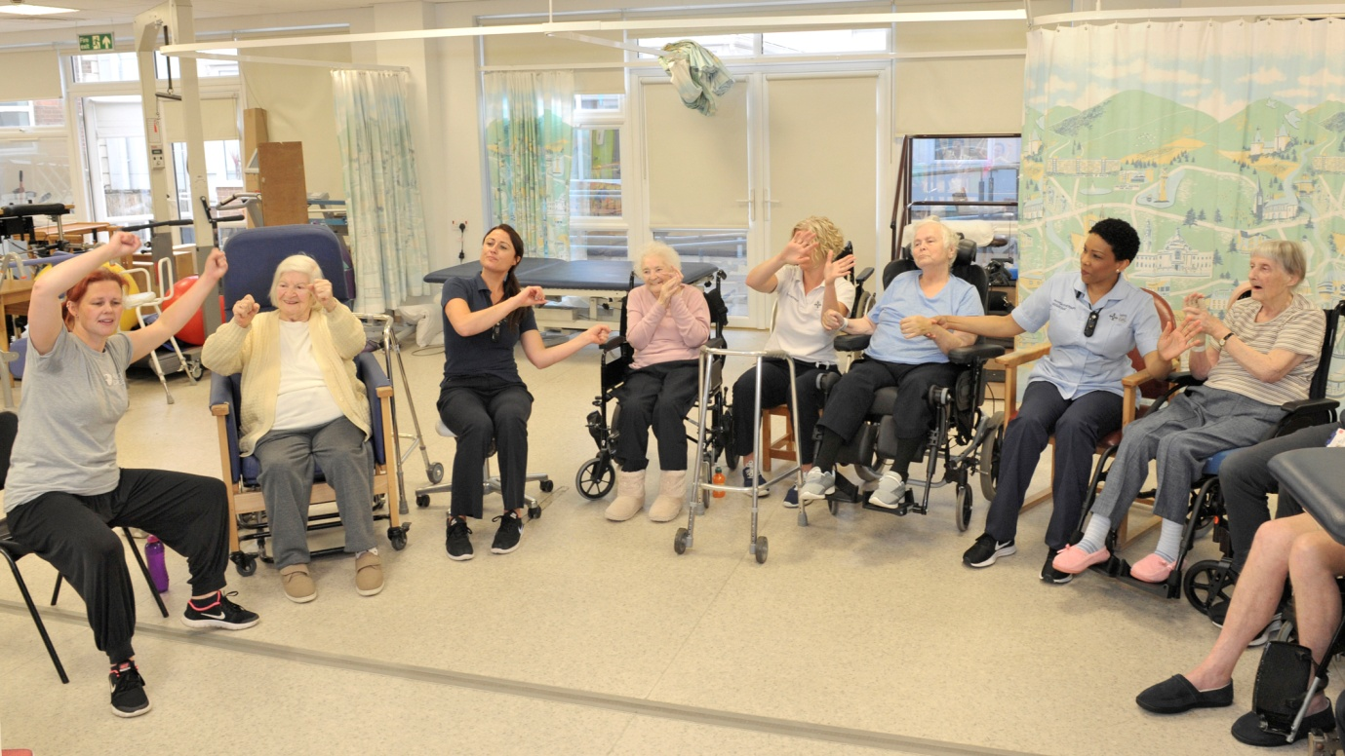

Summary
Stroke sufferers face difficult challenges in recovery, and the aims of this pilot project were to explore how movement and music sessions could increase mood levels, encourage spontaneous movement, reduce stress and anxiety, increase social interaction, and through shared creative activity, a feeling of support and connection.
Six Movement and Music Sessions were delivered to 45 participants, in a variety of clinical spaces, at a cost of £300, to patients of varying ability, staff and visiting relatives. Key points of organisation included a lead Stroke Centre staff member for each session, the provision of ward training and Honorary Contract for Rubicon Dance, and operational organisation via the Arts Team.
Successful outcomes for patients included uplifted mood, enjoyment, conversations and discussion, spontaneous music-inspired movement, and boosted confidence. Staff reported an increased mood, enhanced relationships with patients and staff, and a sense of camaraderie.
The results enabled the provision of further sessions

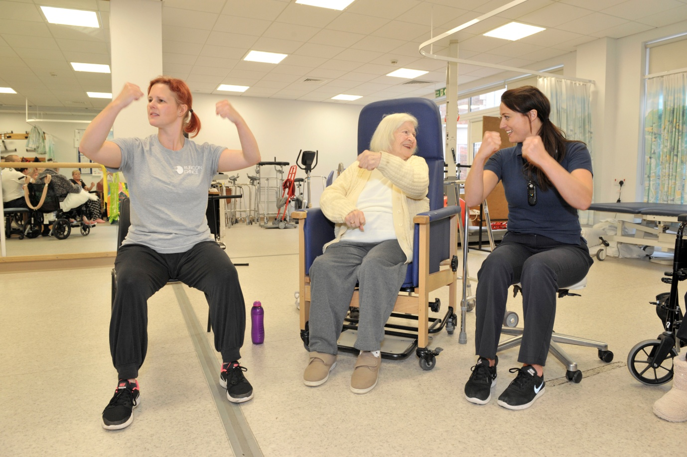

Case Study
Flow: Creativity, Dance and Movement in Recovery
An arts-in-health project exploring how Creative Movement and Music sessions can impact on the mood, confidence and social experience for patients in the UHL Stroke Rehabilitation Centre (SRC).
Title : Flow: Creativity, Dance and Movement in Recovery
Authors and Organisation : Melanie Wotton, Arts-in Health Project Manager,
Simone Joslyn, Head of Arts and Cardiff & Vale Health Charity, Cardiff and Vale University Health Board (CAVUHB)
https://cardiffandvale.art
Partnership : Rubicon Dance (Kathryn Williams, Sharon Teear, Anwen Davies) and UHL Stroke Rehabilitation Centre, SRC (Dr. Susan White, Claire Butterworth, Clinical Specialist Physiotherapist in Stroke, Chris Rees) Sereana Chima (Speech and Language Therapy Assistant)
https://rubicondance.co.uk

Publication date : 12/8/19
Categories : Movement, Dance, Music, Creative Expression
Supporters and Funders : Cardiff & Vale Health Charity, Age Cymru Gwanwyn Festival 2018, Fusion, Stroke Rehabilitation Centre; Wales Millenium Stadium Charitable Trust

Stroke sufferers can face difficult and unique challenges on the road to recovery. Activities which inspire and boost confidence, and which counter low mood or stress and anxiety, dips in confidence, boredom or feelings of social isolation, delivered via a third party, are potentially a positive addition to the clinical day.
Our aims were to explore how regular movement and music sessions could encourage participation, spontaneous movement, social interaction, and through shared creative activity, a feeling of support and connection.
All partners set the framework for the project which provided six Creative Movement and Music Sessions in clinical spaces including four-bed rooms, the Day Room, Gymnasium and bedside, to explore outcome in different areas. Key points of organisation included nomination of a lead staff member to detail patient requirements before each session, provision of ward induction training and an Honorary Contract, and Project Management.
The initial series of 6 sessions for 45 participants included patients with varying physical ability from low level to standing groups, staff and some visiting relatives. During many sessions a staff to patient ratio 1:1 for a 40 minute session was implemented, with enormous commitment and participation from SRC staff. Rubicon’s approach included engagement via musical choice, and a high level of encouragement, interaction and enthusiasm throughout the enjoyable sessions. The evaluation methodology was through staff observation.
Outcomes for patients included increased conversation and social interaction, music-inspired movement, an uplifted mood, discussion around musical choice, and a positive anticipation of the weekly sessions.
“It has made me more confident, especially knowing I had the support of staff at the time”
Outcomes for CAVUHB included greater camaraderie and an increased mood for staff members, better relationships and understanding between staff and their patients, and increased patient confidence and trust in our staff

‘’Patients on the Stroke Rehabilitation Centre have been able to enjoy the fun of moving to music in the Rubicon Dance sessions in small and larger groups. It has been great to see the engagement, pleasure and fun that people have experienced while moving therapeutically outside of their usual treatment sessions. The staff have loved it too.’’
Claire Butterworth

Wider Impact - The pilot project developed with further funding from Fusion and a Stroke Unit Endowment, and other wards within UHL and St. David’s Hospital have secured funding for sessions with the help of Cardiff & Vale Health Charity.

Evaluation - Student Sereana Chima completed mood charts, attached, which show clear improvements in mood for 5 patients and were presented as a poster at the Wales Stroke Conference, 2019. SRC staff reported clear increases in mood, movement attainment and social interaction.
There is a growing body of evidence to support dance and movement classes to aid stroke rehabilitation, including:-

https://www.ncbi.nlm.nih.gov/pmc/articles/PMC5992267/
https://www.cumbria.ac.uk/about/news/articles/articles/specialist-dance-and-health-therapy-for-stroke-patients-to-be-showcased.php
https://www.onedanceuk.org/stroke-survivors-take-to-the-stage-in-a-new-dance-theatre-piece/

TAGS –

Stroke; rehabilitation; health; arts; dance; movement; wellbeing; interaction;

